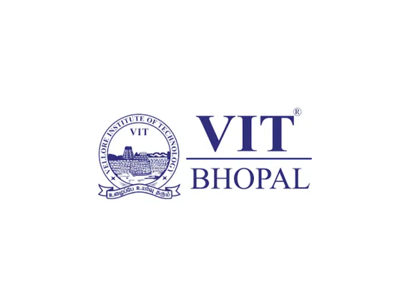

Name – Samriddhi Maudgal
Registration No. -25BAI10416
Branch – B.Tech CSE [AI-ML]
Year- 1st year
Course Name: Digital Literacy
Course Code - CSE0001
Date- 26/03/2026

INTRODUCTION
This Digital Literacy Project was undertaken to develop essential skills required for effective, safe and responsible participation in the digital world. It focused on building both technical competence and awareness of appropriate online behavior.
The project began with the creation of a visual resource explaining the concept and importance of digital literacy. It also highlighted key areas such as safe internet practices, useful digital tools, and maintaining a professional online presence.
In addition, professional profiles were created and updated on platforms like GitHub and LinkedIn to establish a strong digital identity. Basic programming skills were enhanced by completing beginner-level coding challenges, and a digital literacy awareness quiz was designed using Google Forms.
The project also emphasized effective communication through professionally structured emails and promoted responsible social media usage through a detailed checklist of do’s and don’ts.
Finally, a cybercrime case study was developed along with a prevention checklist to raise awareness about online threats and encourage safe digital practices among students.

TASK-01
For Task 1, I created an infographic to explain key aspects of digital literacy in a clear and visually engaging manner. The infographic covered the definition of digital literacy, safe internet practices, professional online presence and email etiquette. The aim was to simplify these concepts so that they are easily understandable and practically useful for students.
I used Canva as the design tool due to its user-friendly interface and availability of templates, icons, and layout features that helped in organizing information effectively. The content was structured using concise text and visuals to enhance readability and retention.
This task helped me understand the importance of presenting information in a structured and visually appealing format. It also improved my ability to summarize key ideas and communicate them effectively. Overall, the activity strengthened both my digital awareness and design skills.

TASK-02
In Task 2, I created my digital portfolio by setting up accounts on GitHub, LinkedIn, and Kaggle. These platforms are important for students to showcase their skills and connect with professional opportunities.
GitHub is used to store and manage coding projects, and I created a profile README to introduce myself and my learning goals. LinkedIn is a professional networking platform where I added my educational details and will use it to connect with professionals and explore internships. Kaggle is useful for learning data science and participating in competitions.
These platforms will be useful over the next four years as I continue to build my skills and portfolio. I plan to upload projects on GitHub, connect with industry professionals on LinkedIn, and practice data-related problems on Kaggle. This task helped me understand the importance of having a professional digital presence.

TASK-03
For Task 3, I explored coding and collaboration platforms. I used HackerRank to complete a beginner-level coding challenge. This helped me understand basic programming concepts and improve my problem-solving skills.
I also created a Google Form titled “Digital Literacy Awareness Quiz” with five questions. The form included both multiple-choice and short-answer questions. The responses were automatically collected in a Google Sheet, making it easy to analyze the data.
These platforms are very useful for academic purposes. Coding platforms like HackerRank help improve logical thinking and programming skills, while tools like Google Forms help in conducting surveys and collecting data efficiently. This task gave me hands-on experience with practical digital tools that will be useful in my academic journey.

TASK-04
For Task 4, I worked on developing professional communication skills and understanding responsible digital behavior. The task included drafting two formal emails-one requesting an assignment deadline extension from a professor, and another expressing interest in a summer internship to a company coordinator. Additionally, I created a checklist outlining the do’s and don’ts for responsible social media use among college students.
The work was completed using a basic text editor, ensuring proper formatting, clarity, and adherence to standard email etiquette rules. The checklist was structured in a simple and organized manner to make it easy to read and apply.
This task enhanced my understanding of formal communication in academic and professional contexts. It also made me more aware of how online behavior impacts digital identity. Overall, it improved my writing clarity, professionalism, and awareness of responsible social media practices.

TASK-05
For Task 5, I developed a fictional case study based on identity theft to understand how such cybercrimes occur and affect individuals. The scenario highlighted how personal information can be misused through seemingly harmless actions like sharing details on unsecured platforms or clicking on fraudulent links. It also covered the typical steps involved in the crime, the target individuals, and the consequences faced.
While working on this task, one surprising aspect was how easily attackers can gather and exploit personal data without immediate detection. It also made me realize how small lapses in online behavior can lead to serious security risks.
As a result, I will adopt safer digital practices such as being more cautious while sharing personal information, verifying sources before interacting online, and strengthening account security using measures like strong passwords and two-factor authentication. This task significantly improved my awareness of cyber threats and responsible online behavior.

CONCLUSION
Overall, this project provided a comprehensive understanding of digital literacy by combining technical skills with responsible online behavior. It helped in developing practical abilities such as creating visual content, building a professional online presence, solving basic coding challenges, and designing interactive forms.
The project also strengthened communication skills through formal email writing and improved awareness of appropriate social media usage. Additionally, exploring cybercrime scenarios and prevention strategies enhanced my understanding of online risks and the importance of digital security.
A key learning outcome was the realization that digital literacy is not limited to technical knowledge but also includes ethical usage, critical thinking, and safe practices. This project has encouraged me to be more mindful, responsible, and proactive in my digital interactions, making me better prepared for academic and professional environments.

REFERENCES
- Canva – https://www.canva.com
- GitHub – https://github.com
- LinkedIn – https://www.linkedin.com
- HackerRank – https://www.hackerrank.com
- National Cyber Crime Portal – https://cybercrime.gov.in

